Happy User’s Guide

Contents
1. Introduction

2. Happy Intro windows

3. Happy Menu
1) Status bar
(4)-5 Event (Addition)
2) Tool bar

4. Happy Operating windows
1) Service list
2) Service information (List)
5. addition - Event

1. Introduction
GM has to use the happy tool in order to move, kick out characters in the game. Also GM can notice and whisper to characters by using the happy tool. If you want to know more information, please refer to below.

2. Happy Intro windows

Status bar
Tool bar

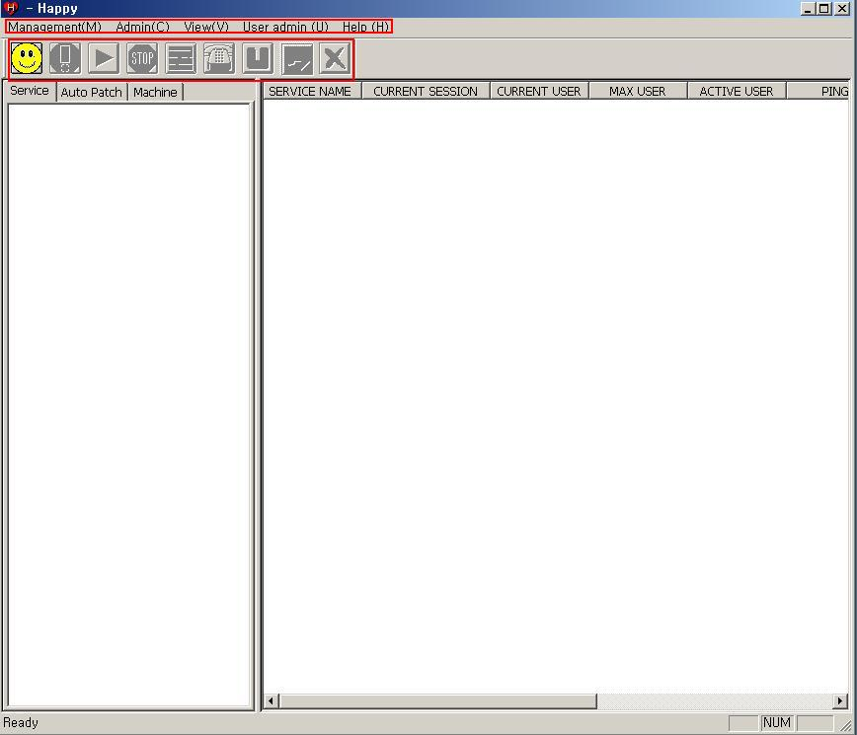
Service Contents
Service Info

3. Happy Menu

1) Status bar

(1) Management (M) - Connect(C) / Cut(D) / Start(S) / Stop(T) / Alarm(A) / Exit(X)

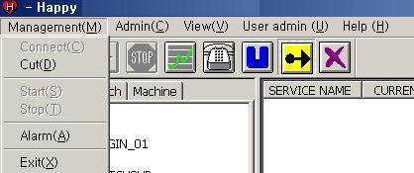

(2) Admin(C) - Service Upload(U) / File Compare(C) / Auto Patch(A) / Happy Data Clear(E) / ChatBan List(C)

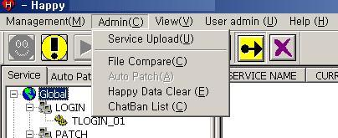

(3) View(V) – View entire service (A) / Tools / Status bar (S) / Service user graphic (G)
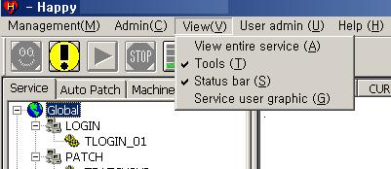

(4) User admin (U) – GM tool (G) / Log record (L) / User admin web (W) / Service Auto Start (R)

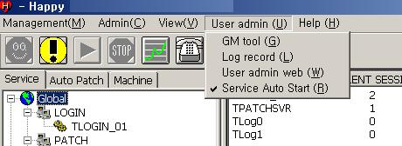

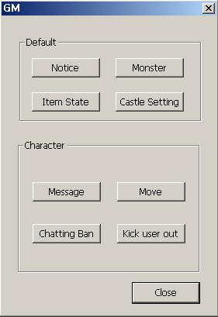
(4)-1. Notice
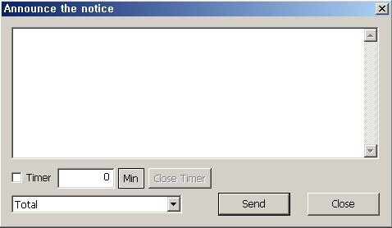
Announce the notice: Message can be sent by setting timer.

(4)-2. Monster
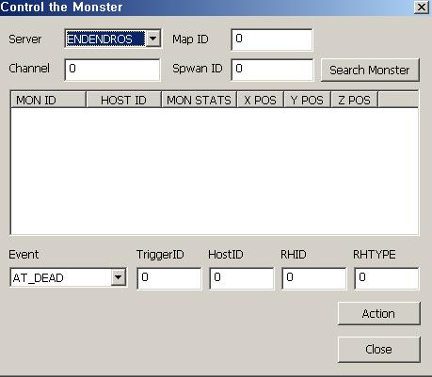

Control the monster: GM can use only [AT_Dead] instruction.

(4)-3. Item State
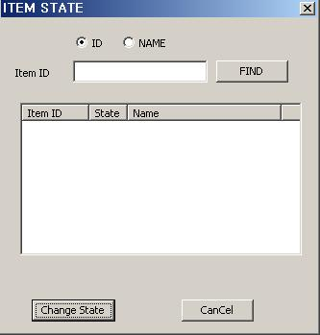
ITEM STATE: GM can control drop condition of items from monsters.
(State: 0 => drop items. / 1 => don’t drop items.)

(4)-4. Castle Setting
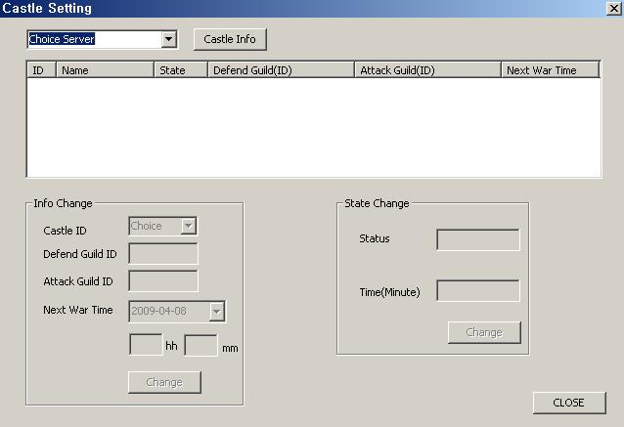

Castle Setting: GM can set siege warfare.

(4)-5. Event
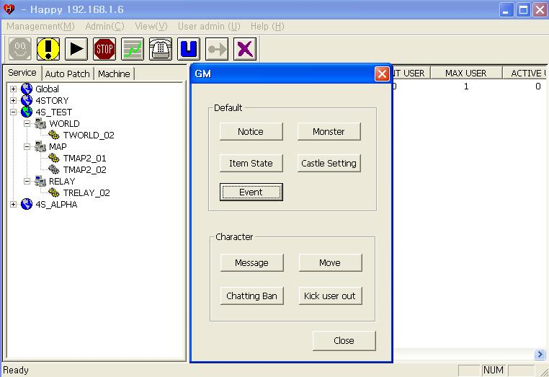
Select Event toggle from GM Tool.

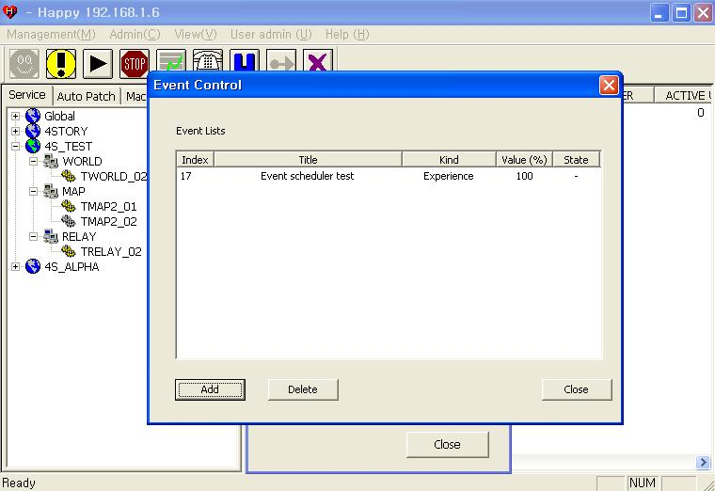
When clicking on Event toggle, Event Control window will be opened and it will show event in progress, and planned events.
From the shown list, Title indicates the title of event, Kind indicates event type, Value indicates increased numeric value, and event in progress will indicate Run on State subject.
Add means adding on an event, and Delete means to delete the event.

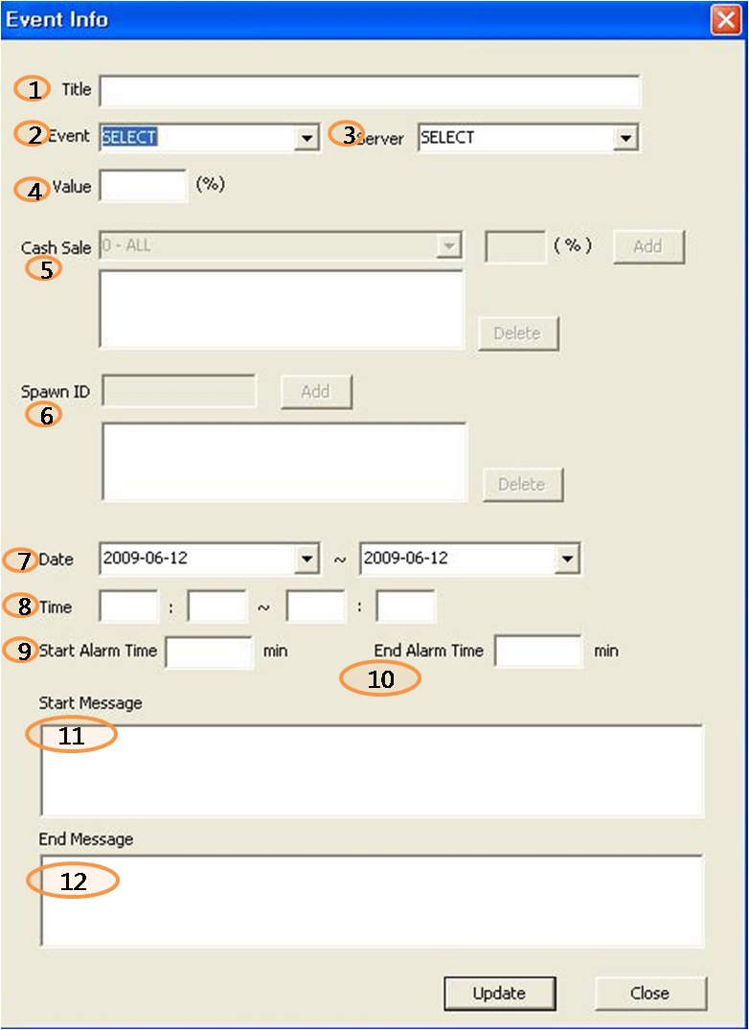
Clicking on Add toggle will open Event Info window.
- Title: This event title will be only shown to Happy Tool user, and it can be confirmed from Event Control screen.

② Event: Selecting Event type. Following list will be shown.
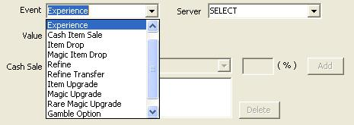
③ Server: Select the server to apply the event.
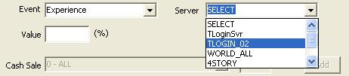

④ Value: Type in the numeric value of event application percentage. When not inputted, it will be following current default value of the server.
Ex) If the current status is 100%, inputting 20% will apply 120% (100% + 20%).
If the current status is 50%, inputting 20% will apply 60% (50% + 10%).
⑤ Cash Item Sale: It shows the list of cash items which will be on Sale Event.
After selecting and inputting sale value, click Add to include the event in the list.
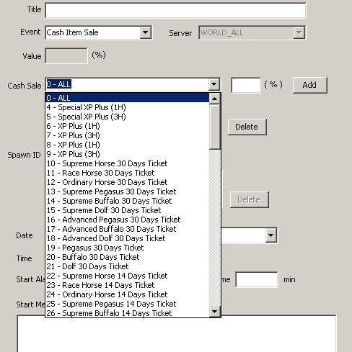

⑥ Spawn ID: When you select Monster spawn from event list, certain Monster will be spawned at the period of time.
Spawn ID is the ID assigned to each Monster. It can be added by the Add toggle.
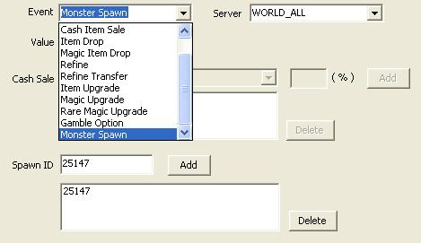
⑦ Date: It means the date of event in progress. The date and time of event can be adjusted.
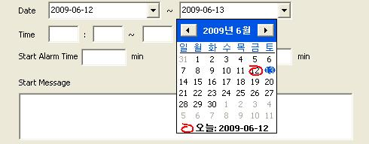

⑧ Time: The time of Event can be modified during the Event period, and it must be in 24 hours range.
⑨ Start Alarm Time: It will output Start Message before the Event starts.
⑩ End Alarm Time: It will output End Message before the Event ends.
⑪ When min is inputted on Start Alarm Time, Start Message will appear before the set X minutes.
⑫ When min is inputted on End Alarm Time, End Message will appear before the set X minutes.

(4)-6. Message
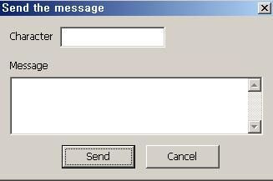

Send the message: GM can send the private message to specific character.

(4)-7. Move
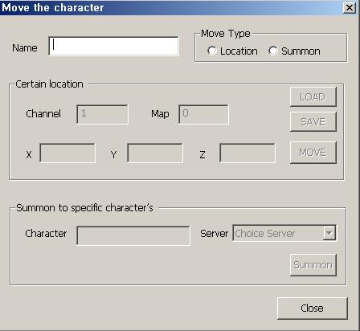
Move the character: GM can move to a certain location or summon to specific character’s location.

(4)-8. Chatting Ban
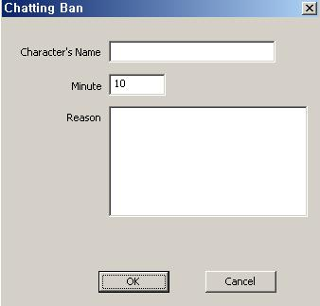

Chatting Ban: GM can ban chatting of specific character.

(4)-9. Kick user out
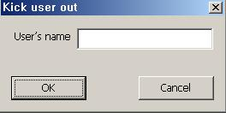

Kick user out: GM can kick out a specific character.

5) Help (H) - Happy information (A)

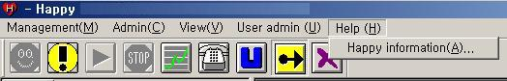

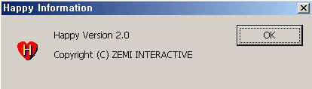

2) Tool Bar



1) Connection: Try to connect to Server

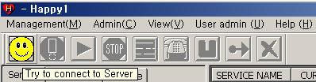

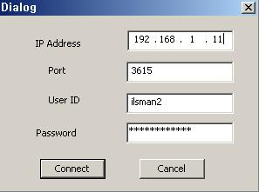

2) Cut: Cut the connection from Server

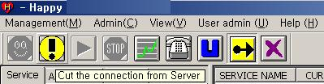

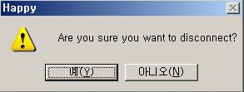

3) Start: Start the selected service

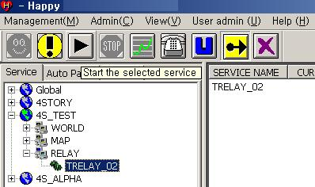

4) Stop: Stop the selected service

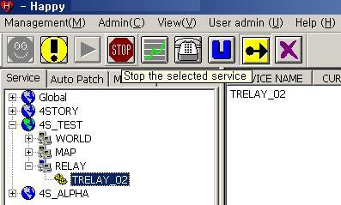

5) Graph: View the graph of service

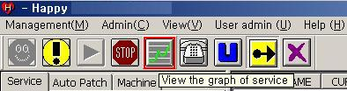

6) Alarm: Service status alarm

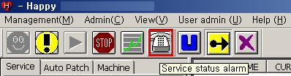

4. Happy operating windows

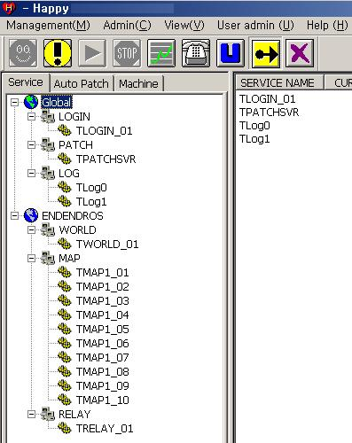

- Service list

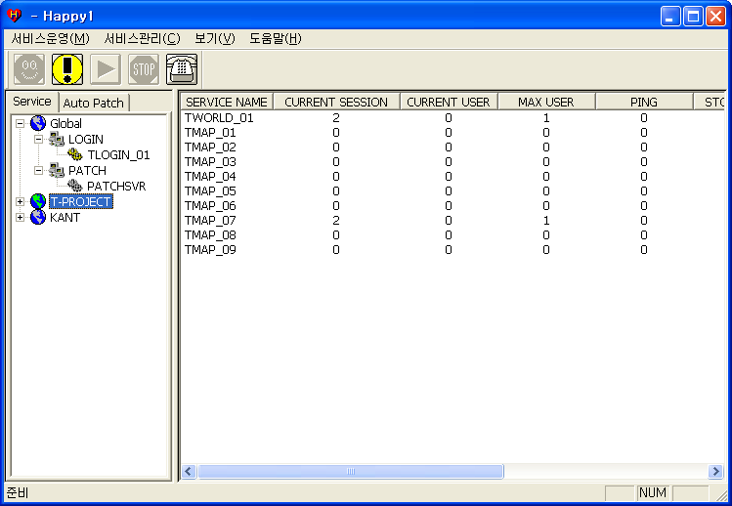

1) Global –> LOGIN -> (TLOGIN_01): Login Server
PATCH -> (PATCHSVR): Patch Server
LOG-> TLog0-1: Log Server

2) ENDENDROS –> WORLD ->TWORLD_01: World Server
MAP-> TMAP1_01~10: Map Server
RELAY–> TRELAY_01: Chat, message, notice etc Server

3) Service status

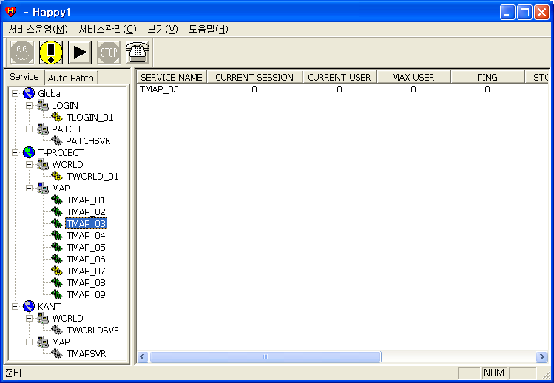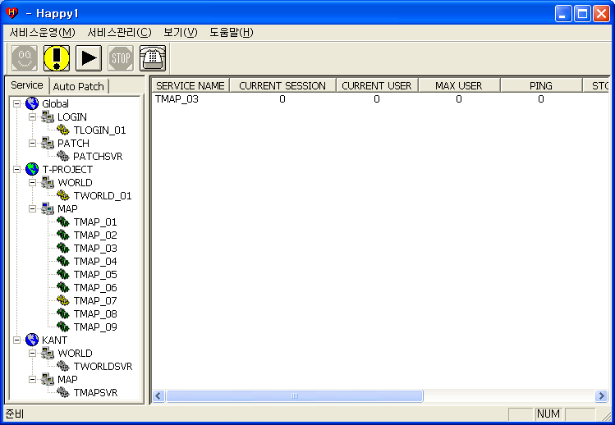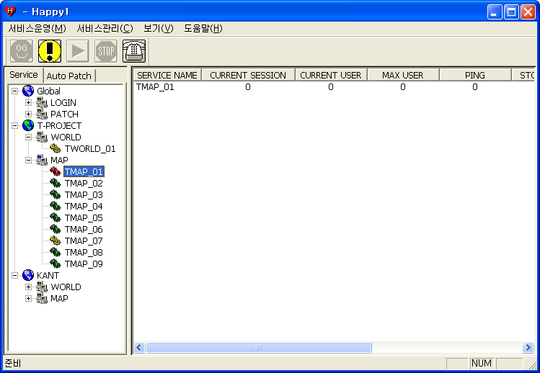
Run Not control Stop Pending

2) Service information (List)

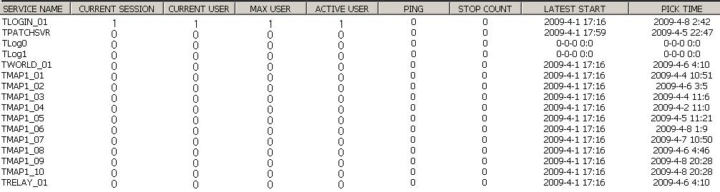

1) SERVICE NAME: name of server

2) CURRENT SESSION: number of current session

3) CURRENT USE: number of current user

4) MAX USER: number of max user

5) ACTIVE USER: cumulative number of active user after server start

6) PING: value of ping

7) STOP COUNT: number of service down

8) LATEST START: latest date & time of server start

9) PICK TIME: date & time of Max User
-TOP-

